Corporate Strategic Planning and Implementation
Name of Student
Name of Institution
Date
- Explain the three major activities involved in strategy evaluation.
The necessity of strategy evaluation is the determination of the effectiveness of an implemented tactic. The assessment also allows the organization in corrective measures where applicable. Therefore, the evaluation needs three critical inputs. The first is the examining of the underlying bases for the firm's strategies. The assessment provides an exact definition and illustration of the foundation that led to the implementation of the plan. A proper grasp on the objectives provides the evaluation team a focus point (Alkhafaji & Nelson, 2013). Secondly, the evaluation requires comparing the actual results with expected results. This assessment highlights the effectiveness of the strategy and provides details that highlight probable failure points for alteration. The last consideration is corrective actions. The evaluation allows for positive adjustments of the strategy so that it can conform to already laid out objectives and goals.
- Do a Google search on "Balanced Scorecard" and images for corporate balanced scorecards? Be sure to include a Balanced Scorecard in your comprehensive case analysis. Summarize the main features here, including a comprehensive diagram.
A balanced scorecard provides significant links between initiatives, targets, measures, and strategic objectives to the vision of the firm. The scorecard requires financial evaluation to highlight the profit and value of the firm. The scorecard should also entail how consumers perceive the organization. Core competencies, from a critical representation of the internal business process, are also vital (Clark, 2017). The final feature highlights that the balance scorecard negates the risk of making the organization obsolete from continuous development and advancement.
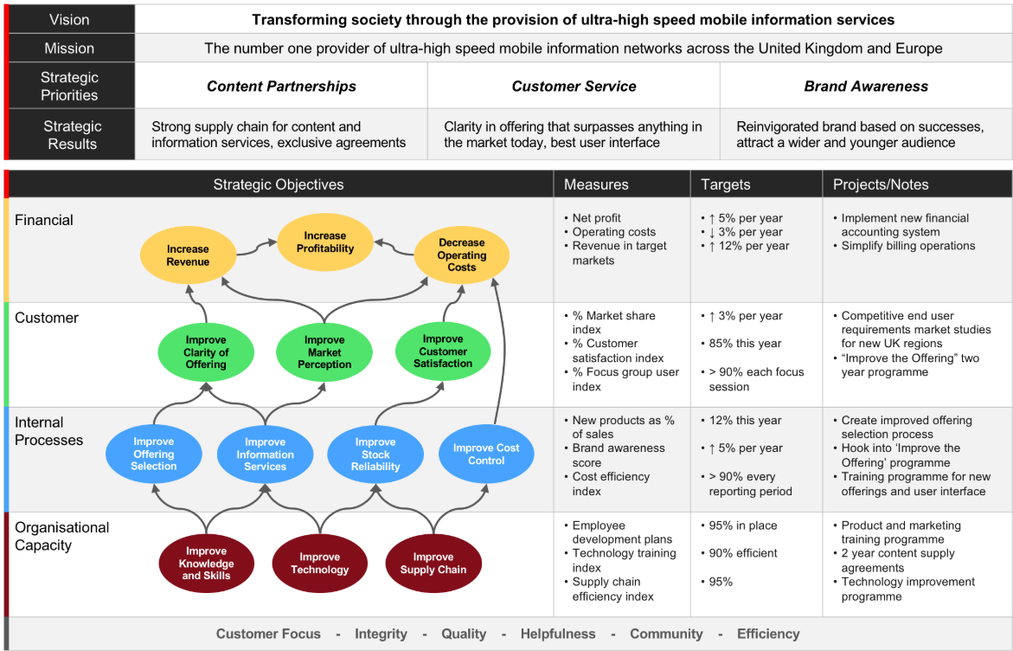
- Explain why companies continually evaluate their strategies, rather than waiting for the end of the quarter or fiscal year to engage in the three core strategy evaluation activities discussed in this chapter.
The external and internal environments for business operations are dynamic; there are continuous changes that tend to be quick and dynamic. Therefore, today's success provides no guarantee for the victory for the next day. It is, therefore, necessary to continually find strategies and evaluate their efficiency and effectiveness in comparison with other competitor firms and industry standards. Strategy evaluation is also a continuous process since it provides relevant information about how to alter the current tactics in place to better achieve the laid out objectives and goals.
- Identify and discuss five characteristics of effective strategy evaluation.
It is necessary that the strategy evaluation by meaningful. It is essential to have a clear focus that is lack of ambiguity in relating the strategy to the objectives and goals of the firm. The second characteristic is the economical consideration of the entire process of evaluation. The trait is significant since it details the necessity of the assessment according to the firm's standards and highlights the need for avoiding too much cost (Rothaermel, 2013). The third characteristic requires conformity of the evaluation to the time dimension of control and information retrieval or dissemination. The trait of time dimension highlights abiding by the stipulated plan for the period allocated to the process of either evaluation or implementation. It is also crucial that the method provides feedback with adequate time left for control functions. The fourth trait stipulates the importance of reflecting the actual picture in the evaluation. Evaluation does not intend to be a blame game, but rather a standing of the firm from internal and external influence. The last characteristic stipulates the importance of not allowing the process to curb or dominate decision-making. The necessity of the evaluation process is the cooperation of all functional areas in control and evaluation strategies. The process is also crucial in promoting trust, understanding, and common cause.

References
Alkhafaji, A., & Nelson, R. A. (2013). Strategic management: formulation, implementation, and control in a dynamic environment. Routledge.
Clark, W. (2017, September 26). Feature of a good balanced scorecard. Retrieved October 13, 2019, from BizFluent: Retrieved from https://bizfluent.com/list-6731029-features-good-balanced-scorecard.html
Rothaermel, F. T. (2013). Strategic management: concepts. New York, NY: McGraw-Hill Irwin.

